R.C.M.P CC Youth Cash Easter Spiel
Easter Monday April 6th 2026
U13 three 4 End Games
U18 three 6 End Games
Win cash win or lose!!

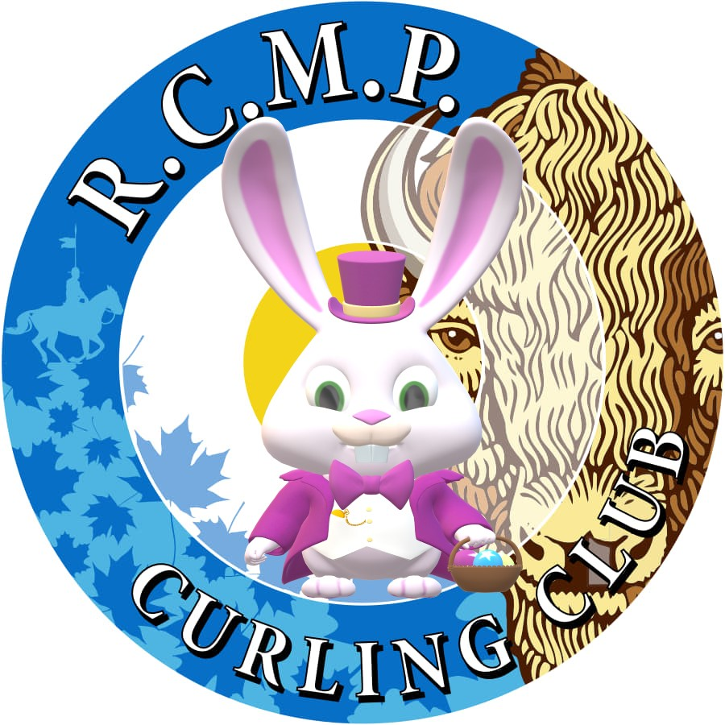

R.C.M.P CC YOUTH EASTER SPIEL
Address: 115 St. Laurent Blvd, Ottawa
Phone: (613) 749-7086
$160 Team Entry
Cash Spiel
Everybody Wins $$$
This will be 3 games:

8 Team U13/Little Rock 4 Ends
Using Normal Rocks

8 Team U18/U15 6 Ends

Start Time:
Little Rocks: 9AM

U18/U15: 10 AM

Lunch and Snack Provided!!!
Great Prizes!!

Send entries to: rcmpccyouthcurling@gmail.com

Once entry is confirmed an E-transfer can be sent to the same email.

Provide Registration info below:

Curling Club Name: ______________________

Phone# _________________________

E-mail address:

Skip _________________

Vice _________________

Second _________________

Lead

