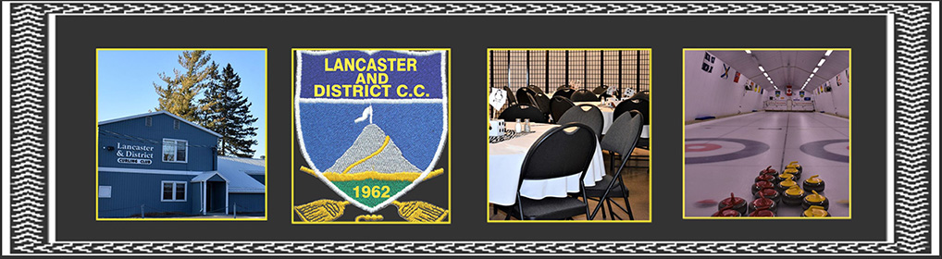
Lancaster & District Curling club

BUSINESS BONSPIEL
January 10th, 2026
Come & mingle or donate a prize
Bring or sponsor a team
Two 6 end games & supper included
Team entry fee $220.
+ $10.00 for Lunch on Saturday, 11:30-12:30
Please note we are limiting to 10 teams,
sign up fast to save your spot, Jan 2nd deadline
THANK YOU FOR YOUR SUPPORT
For more info please contact Lynne Hurtubise at curlingads@gmail.com

